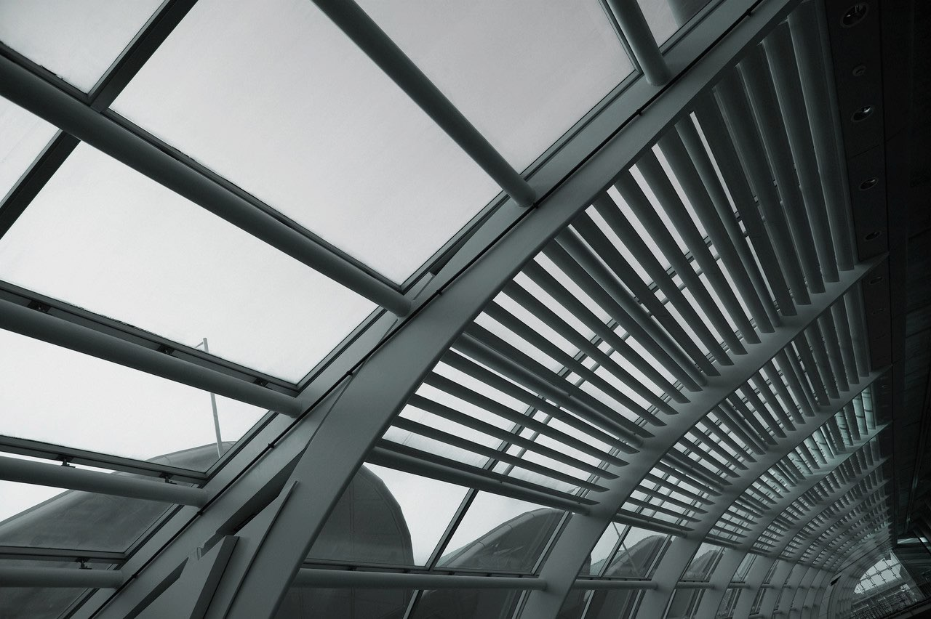
08
Fall
Association for the Scientific Study of Anomalous Phenomena (ASSAP)
ASSAP, PO Box 371, Stroud, GL6 1EL
assapinvestigations@assap.org 0845 652 1648
ASSAP Investigation Report
Case ID Number: This will normally be provided by the ASSAP Investigation Coordinator

Author/s of report: Completion of the report is the responsibility of the lead investigator

Dates of Investigation: From commencement to completion

Date report completed:

Investigators: Include all team members.

Format: MS Word (.docx) is preferred. Supporting material incl. photos, videos and measurements data should use the original file format wherever possible.
Compiling your investigation report

What is required

- The completed report should commence from the point that the client made contact with you. You will normally be provided with a copy of all prior correspondence and notes pertaining to the client’s original request to ASSAP for assistance; this should also be included as part of your report submission.
- The report should be presented in a chronological order with the dates and times indicated for all actions incl. client communications, interviews and visits. You should supply copies of all correspondence with the client and with any other relevant individual or organisation. Recordings, photographs or video footage should be supplied unedited and must include the date and time the recording or image was made.
- The report must also include a completed Statements of Confidentiality and Data Protection AND signed Consent forms covering each agreed action or activity.
- It is a requirement that written consent must be obtained from the client (or their appointed representative) prior to you carrying out any action or activity incl. interviews, taking pictures and videos, gathering data and making any measurements
- If the case involves any individual who may be considered to be vulnerable, you should include any additional steps taken to meet the needs of that person.
- Written consent may be given using email, electronic document or in writing. Were verbal consent has been given, this must always be followed at the earliest opportunity by written consent and should include a description of the actions and activities that were verbally consented to.
- Client confidentiality must be observed at every stage of the investigation (including after completion). You must not share any information pertaining to the case with any other party, at any time, without first obtaining the written consent of both the client and an appointed ASSAP Officer.

Interviews, emails and telephone conversations

- Whenever possible, you should record all interviews or conversations pertaining to the case. In instances where recording is not possible or is not allowed, you should include a detailed transcript of the interview made as soon as possible after the interview or conversation has concluded.
- The transcript should include ALL questions that were asked as well as all of the responses. In the case of telephone conversations, you should make a detailed record of the conversation; noting ALL questions and responses. Each recording and transcript should include the date and time the conversation took place.
- Include copies of ALL emails pertaining to the case between you, the client or any other interested party. This also includes emails pertaining to the case between members of the investigation team.
- The report should contain ALL items of supporting material i.e., diagrams, photographs, videos and any other relevant material obtained or supplied by witnesses, third parties or members of the investigation team. Supporting items should be clearly identified and include a note of the date / time it was received or obtained.
- Photographs, videos and audio recordings should be supplied unedited and whenever possible in their original format. Recordings, photographs or video that have been edited or altered in any way during your investigation must be documented in the report, including a description of the alterations that were applied and the reason for making them e.g., for purpose of analysis, enhancement etc. You should include copies of any intermediary recordings or images that were made as part of this process.

Location survey information

- Where it is relevant, you should include a description of the physical layout of the location in as much detail as possible. This may include; maps, diagrams, photographs and measurements or estimates of physical dimensions, distance, direction, speed, viewpoint etc. Where estimations have been used this should be noted.
- Indicate the source of each item of information you have gathered; for example, this may have been an internet page, local archive or library. This may include historical records and physical data. You should note of the date / time when it was obtained.
- In some cases, previous investigations and examinations may have been carried out; these may be worthwhile looking at. Whenever you have reviewed previous investigation material or accounts of phenomena linked to the location, this should be noted in your report indicating the source of the material you used and whenever possible including a copy of any information you used.
- If data has been obtained by means of measurement of physical variables e.g, temperature, electromagnetism etc. or by recording equipment (audio or video) and cameras etc. the report should indicate how each item of data was obtained; noting the equipment that was used, its precise location and the method of its use. Each item of data should also include the date / time it was obtained.
- If any experiments were undertaken during the investigation, these should be documented and include the reason for carrying out the experiment. (Undertaking experiments on the spur of the moment or without a supporting hypothesis will rarely be helpful and in some circumstances may prejudice or hamper the investigation).

If you have any further questions or queries relating to completing your report, please contact the Investigation Officer.

